Arrow Vale Sports Centre
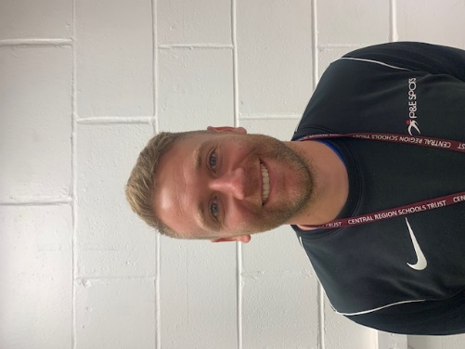  David Phelan –  pandesports@gmail.com | Senior Lead for Safeguarding
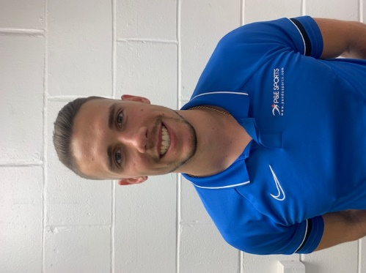  Daniel Noke – sportscentres@pandesports.com | Deputy Senior Lead for Safeguarding

In the event of an emergency please acquire our contact number from a member of our on-duty staff.

